Thank you for trying out our bot! THIS IS VERY IMPORTANT INFORMATION, so please read carefully! There are 3 steps to installing this bot fully with all functions! Don’t worry, after the 1st step, the other steps are extremely easy. This will only take 2-5 minutes tops.

Before installing this bot into your server, you MUST do the following steps:

STEP 1:

There is a built in mute function inside this bot. For this to function in your server, you must do the following:

1st, you need to create a mute role. This role MUST be named “mute” without any capitals. Do not edit the permissions for this role, the bot will do this automatically.



2nd, you need to create a soft mute role. This is also case sensitive.



Note: The role colors do not matter. The only important thing that matters is they are named exactly as stated here. (Plus the mute role’s color is automatically changed to a dark grey, you can change the soft mute role color to anything you want)

It is highly suggested you consider putting these roles at the very top of the role roster.

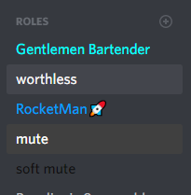

You can also put it below staff members so they can apply the role manually

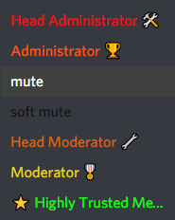

The main important thing is these roles MUST be at the top of the role list/roster, at least somewhere around where the staff roles are.

STEP 2: (I suggest quickly inviting the bot now, scroll down, then scroll back to here)

Your bot has its own settings that you can manually toggle. Note, more settings may come in the future, but as of right now you can see the current settings by doing !gG settings.

The first setting you need to set up (If you so choose) is the staff commands option. Staff commands are disabled by default. To do the 3rd step and give staff members access to staff commands, you must put in this:



If everything works correctly, you should see this:

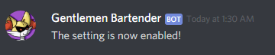

Side Note:

Like all settings, this can be toggled off as well. This is what you will see if you toggle the staff commands off.

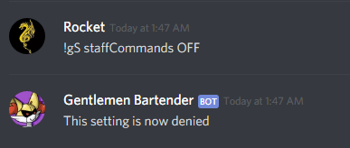

STEP 3:

You likely have staff members in your server, so I highly suggest you set up staff roles.



This is a NEEDED function for the bot to operate. It needs both a moderator AND admin role, not one or the other. Here’s what happens when you perform this action:

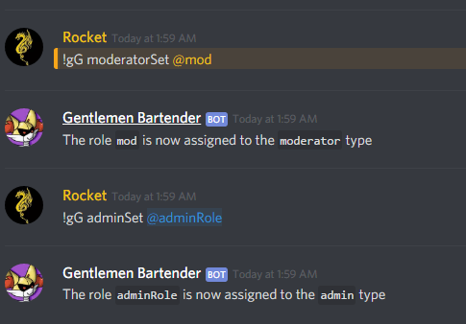

If you have done all of these steps, congratulations! You are now ready to install your bot! Your information should now be entered into my programs code. Enjoy the bot my friend!

When the bot joins, it automatically creates its own role. It is HIGHLY suggested you move this role to the very top of the list. Otherwise there may be bugs with administrative functions.

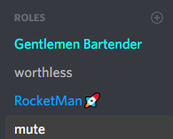

Lastly, I should mention that the mute roles automatically set up the permissions for every individual channel (mute role permissions) so here’s two things I would suggest:

ONE:

Create a channel named mute. Do not edit any permissions, even the @everyone role, the bot will do this automatically.



In this mute channel, I suggest you write a message telling them why they are muted.

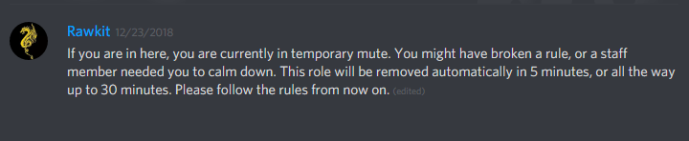

TWO:

I highly suggest you mute a random individual using !gM mute. This is for a good reason.

When a mute command is used, the bot fetches your servers text channels and voice channels, and it tests to see if it needs to edit permissions for the specific roles requested. If you have 30 or more channels, this process could take 30 seconds, possibly upwards to a minute if you have a ton of channels. However, muting one random person will make the bot do this process, meaning it won’t have to do it again.

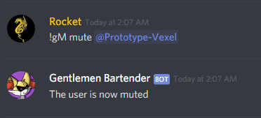

Bot invite link:  
  
<https://discordapp.com/api/oauth2/authorize?client_id=526216919074734101&permissions=8&scope=bot>